***PAAREES PERFUMES***

***Christian Diors***

***FOR MEN***

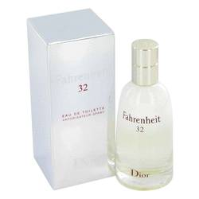

# *Fahrenheit 32*

***Description:***

Fahrenheit 32 by Christian Dior Cologne. A modern and pleasing men's fragrance, Fahrenheit 32 by Christian Dior blends sweetness with herbal spice in an innovative, one-of-a-kind blend. Succulent orange blossom notes layer with woody vetiver and rich vanilla notes to create an intoxicating aroma that attracts attention. The harmonious scents are appropriate for casual wear and pleasant to be around. Use Fahrenheit 32 by Christian Dior daily to develop your own signature scent. It embodies the true nature of masculine style.